 | Testing and Training Center of Farm Machinery  Department of Farm Machinery and Power Engineering  College of Agricultural Engineering and Technology  Junagadh Agricultural University  JUNAGADH – 362 001 (GUJARAT) | 
P | Phone : (0285) 2672080-90, Ext. 390 & 484; Fax : (0285) 2671018

SPECIFICATION SHEET OF PLASTICS MULCHING LAYING CUM DRIP PIPE LAYING MACHINE (TRACTOR MOUNTED)

4. SPECIFICATIONS
1 |  |  | General:
 |  |  | a) |  | Name |  | :
 |  |  | b) |  | Type |  | :
 |  |  | c) |  | Make |  | :
 |  |  | d) |  | Serial Number |  | :
 |  |  | e) |  | Model |  | :
 |  |  | f) |  | Year of manufacture |  | :
 |  |  | g) |  | Recommended source of power as per applicant |  | :
 |  |  | h) |  | Selling price in India |  | :
2 |  |  | Constructional Details
2.1 |  |  | Main frame / Chassis:
 |  |  | a) |  | Constructional details |  | :
 |  |  | b) |  | Size (mm) |  | :
 |  |  | c) |  | Ground clearance (mm) |  | :
2.2 |  |  |  | Ridger / Bed former / Forming boards
 | a) |  |  | Constructional details |  |  | :
 | b) |  |  | Distance between forming boards (mm)
 |  |  |  | Front side |  |  | :
 |  |  |  | Rear side |  |  | :
 | c) |  |  | Total no. of holes at front |  |  | :
 | d) |  |  | Total no. of holes at rear |  |  | :
 | e) |  |  | Dia. of hole (mm) |  |  | :
 | f) |  |  | Hole to hole distance (mm) |  |  | :
2.3 |  |  |  | Pressing plates (Forming level plate) |  |  | :
2.4 |  |  |  | Press roll |  |  | :
2.5 |  |  |  | Press wheels
 |  | a) |  | Nos., type and material |  |  | :
 |  | b) |  | Size |  |  | :
 |  | c) |  | Hub diameter (mm) |  |  | :
 |  | d) |  | Hub length (mm) |  |  | :
 |  | e) |  | Axle diameter (mm) |  |  | :
 |  | f) |  | Method of fixing |  |  | :
2.6 |  |  |  | Plastic mulch roll carrier (Roll holder)
 |  | a) |  | Material and Length (mm) of roller |  |  | :
 |  | b) |  | Method of fixing |  |  | :
2.7 |  |  |  | Roll guide |  |  | :
2.8 |  |  |  | Plastic film covering assembly (Soil inverter) / Plastic Film Covering Shovel
 |  | a) |  | Type
 |  | b) |  | Material and size (mm)
 |  | c) |  | Share bar (Bar-point)
 |  |  |  | Numbers |  |  | :
 |  |  |  | Type |  |  | :
 |  |  |  | Material and dimensions (mm) |  |  | :
 |  | d) |  | Method of fixing |  |  | :
2.9 |  |  |  | Drip pipe holder
 |  | a) |  | Constructional details |  |  | :
2.10 |  |  |  | Fertilizer hopper
 |  | a) |  | Constructional details |  |  | :
2.11 |  |  |  | Type of hitch and its details
 |  |  |  | a) |  | Type | :
 |  |  |  | b) |  | Constructional details | :
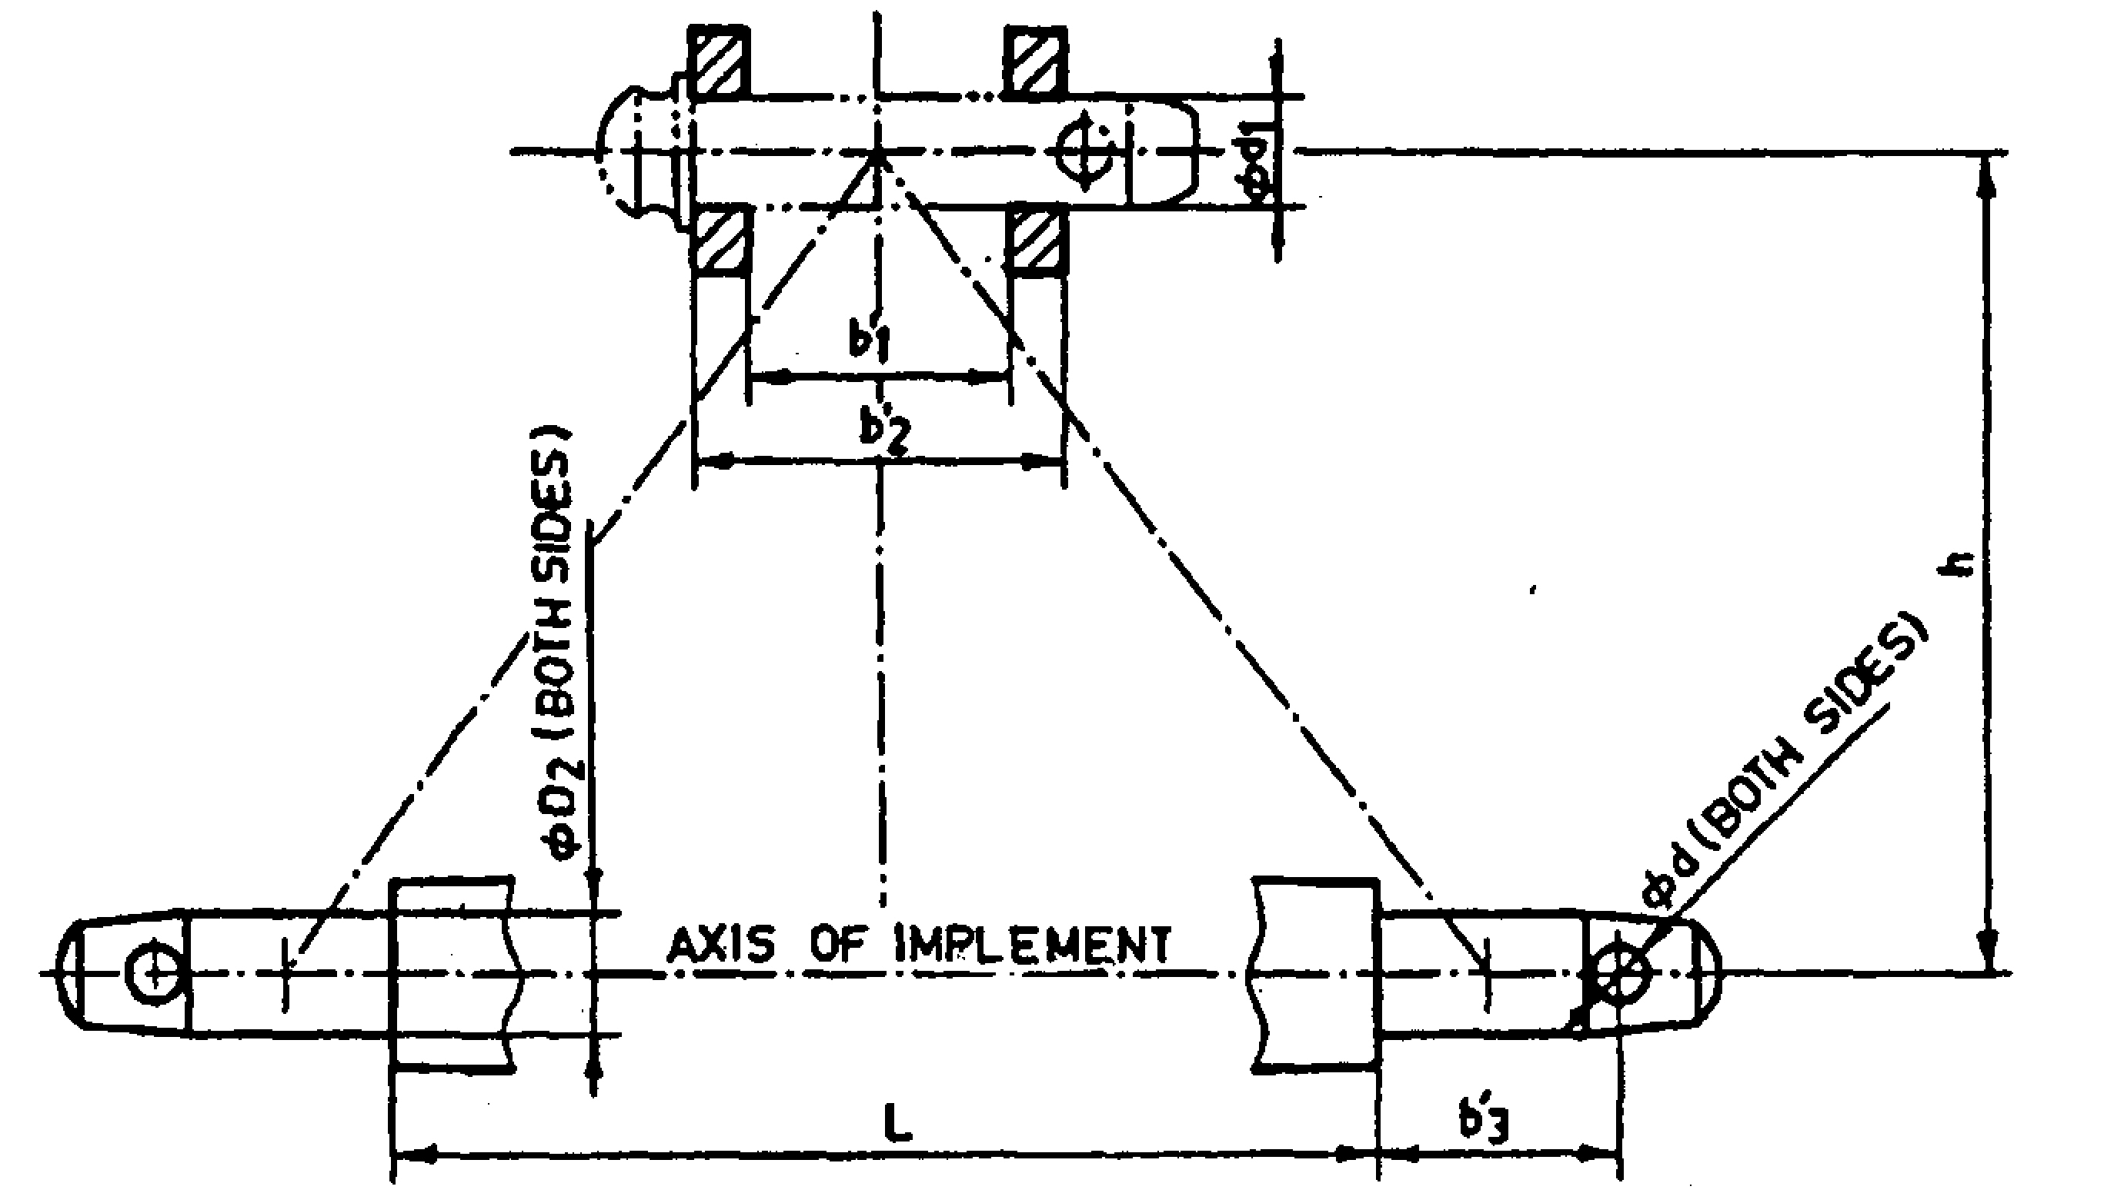

Sr. | Dimen. | Description | As observed
Upper Hitch attachments
1 | - | Dia. of hitch pin
2 | d₁ | Dia. of hitch pin hole
3 | b’₁ | Width between inner faces of yoke
4 | b’₂ | Width between outer faces of yoke
Lower hitch points
5 | - | Dia. of hitch pin
6 | D₂ | Dia. of hitch pin hole
7 | b’₃ | Linch pin hole distance
8 | l | Lower hitch point span
Other dimensions
9 | d | Dia. of linch pin hole (upper hitch pin)
10 | d | Dia. of linch pin hole (lower hitch pin)
11 | h | Mast height

3 | Overall Dimensions (mm):
 | a) | Length | :
 | b) | Width | :
 | c) | Height | :
 | d) | Mass, (kg) | :
4 | Color of Implement |  | :

Place:
Date:
Signature : _________________________

Name : _________________________

Designation: ________________________

